**Exercise 5 – Pulling and Pushing to Git Hub**

Let’s pull and push all the DN4.0 Exercises from one of my other local PCs.

This PC has up to week 5 of DN 4.0 exercises.

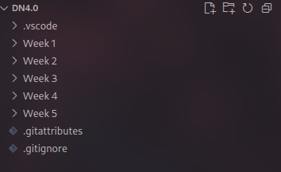

Let’s do git pull to pull all the exercises from Git Hub.

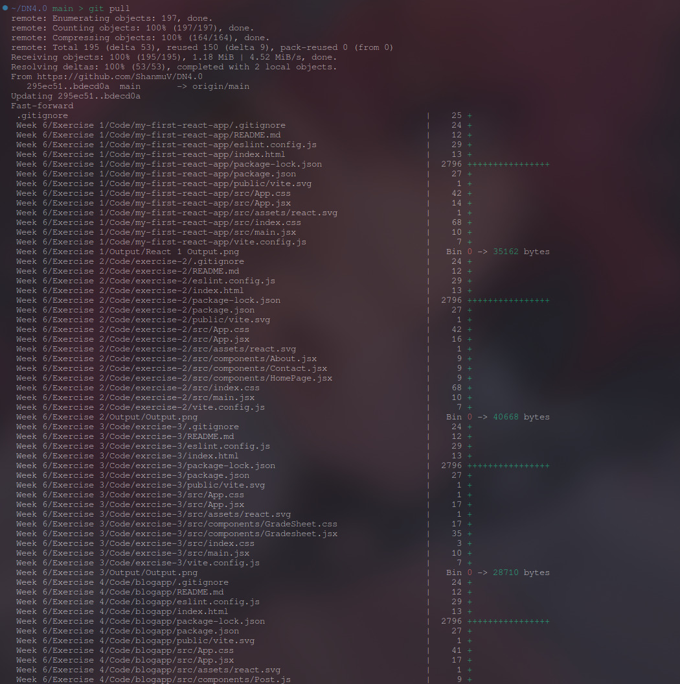

Now, all of the Exercises were pulled to the local repo. We can finish this course by uploading / pushing this document to GitHub. By running git push.